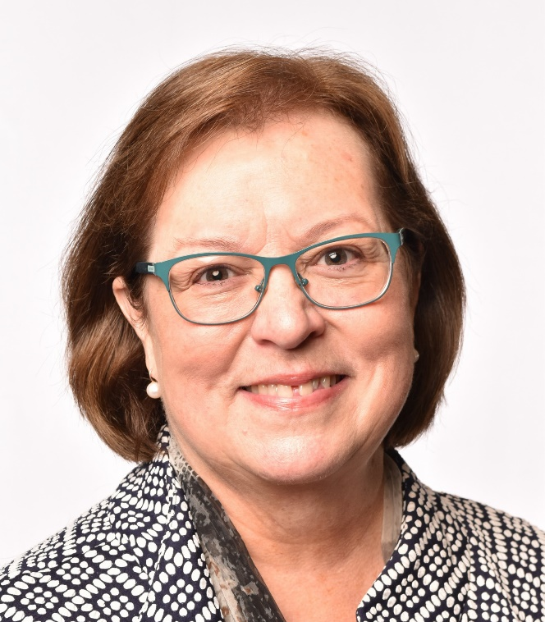

BIOGRAPHY: Dr. Joyce Loveday

Dr. Joyce Loveday has served Clover Park Technical College in the position of President since June, 2016; however, she’s been an integral part of the college community since 2002, serving in the roles of Dean for Business and Computer Technology, Assistant to the President, Associate VP for Instruction, and VP for Student Learning. Dr. Loveday’s cumulative higher education experience spans over 30 years and includes experience as faculty member, department chair, and dean. Expanding access to quality education and preparing students for career success is a priority for Dr. Loveday. She’s proud of the role CPTC plays in the health and strength of our community as we educate and prepare graduates for success in tomorrow’s workforce.

Dr. Loveday holds a Bachelor of Arts degree from Wheaton College, a Master of Business Administration from Idaho State University, and a Doctorate of Philosophy in Education from Oregon State University with an emphasis in Community College Leadership. She’s actively engaged in the community as past president of Clover Park Rotary, member of Lakewood’s Promise, board member for the Lakewood Area Support Alliance (LASA), and board member for the Tacoma-Pierce County Chamber of Commerce.

