Frequently Asked Questions (FAQs)

Table of Contents

General Open Computer Lab FAQs 2-4

Wi-Fi FAQs 5-6

Student Email FAQs 7-9

Printing FAQs 10-11

Microsoft Imagine Academy FAQs 12

General Open Computer Lab Frequently Asked Questions

Where is the open computer lab located?
The open computer lab is located at the Lakewood Campus in building 15, room 104.

What are the hours of the open computer lab?
Winter, Spring and Fall Quarters
Mondays, Tuesdays, Thursdays, Fridays 8:00am – 4:30pm
Wednesdays 8:00am – 8:00pm
Summer Quarter
Mondays, Tuesdays, Thursdays, Fridays 8:00am – 4:30pm
Wednesdays 8:00am – 6:00pm
The computer lab is not open during weekends, holidays, breaks between quarters, or in-service days.

How many computers are available in the open lab?
There are 47 PCs, three (3) Macs, and one (1) PC ADA complaint station.

Who can use the open computer lab?
Currently registered students (priority users) and staff are welcome to use the computers in the open lab. Public users are welcome to use the computers and must be signed in to a computer by a staff member.

What software is available on the computers?
The open lab computers have Microsoft Office Suite (Word, Excel, Powerpoint, etc), Adobe Reader, Keyboarding Pro, Respondus Lockdown Browser, and other web browsers. Two of the PCs in the lab have AutoCad installed.
The ADA station is equipped with a sit/stand station and ergonomic chair. Software installed on the ADA workstation includes ZoomText, JAWS, Dragon, FSReader, Abbyy FineReader with ScanSnap, Fujitsu Image Scanner and USB MonoMouse Print magnifier.

How do I sign-on to the computers in the lab?
Students will log-on to the computers in the lab using their Wi-Fi username and password.

Can I save my work on the lab computers?
It is highly recommended that all computer lab users bring a USB flash drive to save their work.

Can I schedule a proctored test?
No. The computer lab is first come first served. The computer specialist does not proctor tests. Please see your class instructor for a scheduled time and location to have your test proctored.

I need software X installed. Can I install it, or can I have it installed?
Students do not have access to install software in the computer labs. Requests for software installs should be submitted to you program faculty. Depending on the number of requests and site licenses available, the request may or may not get approved.

Can the computer specialist fix my computer/laptop?
No. CPTC staff members are prohibited from working on personal devices of students or computer lab users. However, the Computer Networking and Information Systems Security (CNISS) program has a helpdesk available where students can work on your personal devices (desktops and laptops only).

Can I schedule an appointment with the computer specialist for one-on-one assistance?
No. The computer specialist is available to assist students with their needs. Students are assisted on a first come first serve basis.

Can the computer specialist tutor me on basic computer skills?
No. CPTC offers an Introduction to Computer course which is highly recommended for those students needing to increase their computer skills.

Can I get help registering for classes?
Yes. The computer specialist is available to assist students with class registration. Students may wish to have their education plan available as a guide for registering.

Can I get help completing my FAFSA application?
No. The computers are available for your use, however it is recommended that all financial aid related questions be directed to the Student Aid and Scholarship office located in building 17.

Can I get help with my homework in the computer lab?
The computer specialist is available to assist you with hardware/software programs and to answer general application questions. If you are struggling with course content, the Tutoring Center has tutors available for many of the program areas. The Tutoring Center is located in building 15, room 113K.

Can I get help with Microsoft Office applications?
Yes. The computer specialist is available to assist students with MS Office applications.

Can someone proofread my essay in the computer lab?
The Tutoring Center has peer and staff tutors that can assist students with course work.

Can someone help me with research and citing sources?
The college librarians can assist with research, APA, and MLA formatting. The Tutoring Center is also available to assist.

Does the computer lab have headphones and/or webcams available?
Plug-and-play headphones and webcams are available for checkout at the main Library Circulation desk.

I left my USB flash drive (jump drive) in the computer lab. Is there a lost and found?
Items left in the computer lab are stored in the Security office. The Security office is located in building 12.

Who can help me with creating a resume?
Please schedule an appointment in the Advising office (253) 589-5548 to meet with a career advisor. It is highly recommended that you bring a draft of your resume to the appointment.

As a student, do I have free access to Microsoft Office for my personal devices?
Yes. Students and staff may do a web search for the following: “Free Office 365 for Education” or access the webpage here: Free Office 365. Once you have accessed the page, you will need to type your student or staff email address and click the Get Started button.
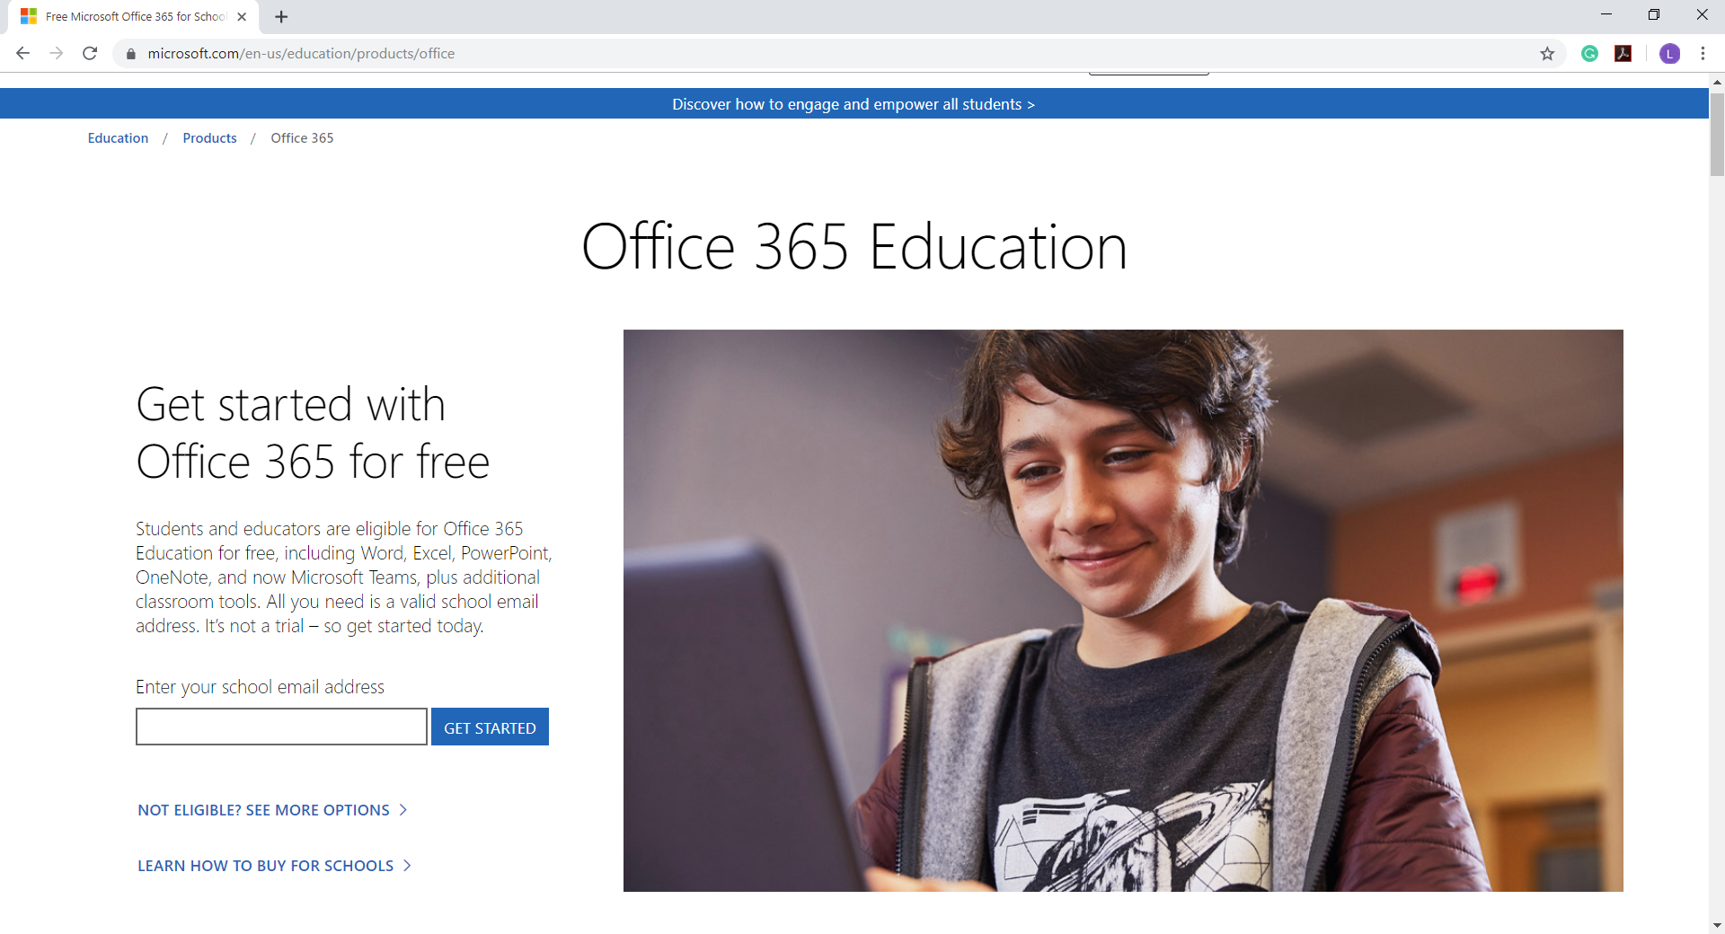

Wi-Fi Frequently Asked Questions

Where can I create or reset my Wi-Fi password?
Wi-Fi password reset kiosks are located in the following locations:
Lakewood Campus
- Building 2, Room 109 (Veteran’s Resource Center)
- Building 15, Room 104 (computer specialist is available to assist)
- Building 23 (ASG Office)
South Hill Campus
- Lobby

What Wi-Fi network do I join if I’m a student?
Students should connect to the CPTC_Students Wi-Fi network.

Can I use the student Wi-Fi at home?
No. All CPTC Wi-Fi users must be on campus (Lakewood or South Hill) to use the Wi-Fi network.

What information will I need to reset my Wi-Fi password?
Students will need their Student Identification number (SID) and PIN code. The PIN code is the same code used when registering for classes. In most cases, the PIN is the student’s birthdate in this format: MMDDYY. If you do not have your SID handy, a photo ID should be shown to the computer specialist to retrieve your SID.

What are the rules for creating a Wi-Fi password?
- Minimum length is 10 characters.
- Must contain at least 1 Upper Case character
- Must contain at least 1 Lower Case character.
- Must contain at least 1 number or 1 special character (special character examples: ! @ # $ % & *).
- Cannot use your last four Wi-Fi passwords.
- Cannot use your first or last name in your password.

Is there a default password for Wi-Fi?
Yes. The username for students is the last name + last four digits of the student identification number (SID). The default password is in the following format: cptcDDMmmYYYY for example a birthdate of June 10, 1999 would be cptc10Jun1999. Note: The first letter of the birth month is capitalized.

My classes are at the South Hill campus. Is there someone that can help me with my Wi-Fi password?
Yes. You may call 253-589-5820 to speak with the computer specialist and they can work with you over the phone to reset your password.

Does my Wi-Fi password expire?
Yes. Student Wi-Fi passwords expire at 120 days. Approximately once per quarter students will need to reset their Wi-Fi password.

I reset my Wi-Fi password. Why can’t I update the password on my cell phone?
In most cases, you’ll need to forget the Wi-Fi network and then reconnect to the CPTC_Students network. This will allow you to type in your new Wi-Fi password.

I have an android cell phone. What settings do I use to connect to CPTC_Students?
Many android users will need to populate the following fields which have dropdown menus:
- EAP Method: select “PEAP”
- Phase 2 Authentication: select “MSCHAPv2”
- CA Certificate: select “Do Not Validate” or “Unspecified”
- Identity: type your last name + last four digits of SID (same as username)
- Anonymous Identify: leave blank
- Password: type the default Wi-Fi password or the password you created

My Wi-Fi username and disappear on my laptop as I’m typing. How can I access the Wi-Fi?
Laptops with Windows 10 Operating System (OS) have a timing feature for the Wi-Fi log-in. For those of us who are not speedy typists, the computer specialist suggests opening notepad or Word and typing in either your Wi-Fi username or password. Next you’ll copy the username or password and paste it into the appropriate fields. The computer specialist is available to assist if you have any problems.

Student Email Frequently Asked Questions

What is student email?
Your student email is a free and required account provided to students as a tool for sharing important college information. Student email is the only mode of communication the college uses to send students up-to-date college information about campus closures, deadlines, scholarship opportunities and upcoming events.

How can I activate my student email?
Your college issued email address is created within two (2) business days of your application acceptance. Your email is created as a google account (Gmail).

What is my email username and password?
Your username is composed of your last name (in lowercase letters) as recorded in the Registrar’s Office, and the last four digits of your CPTC Student ID number (not your Social Security number), followed by “@student.cptc.edu”. Your default password is your date of birth. Enter your date of birth as YYYYMMDD. Example: July 17, 1980 is 19800717. We recommend that you immediately change your password to prevent misuse of your account.

How do I change my name on my student email?
Please see the computer specialist in building 15, room 104 to update your name and email address (picture identification is required). Students must also see Enrollment Services in building 17 to update their name in the student management system.

What if I forgot my password?
Contact the computer specialist in the computer lab in building 15, room 104 or call (253) 589-5820.

How do I change my student email password?
We recommend changing your password as soon as possible — and you should use a secure password that uses both numbers and letters. Here's how to change your password:
- Log in to your Gmail account.
- Go to your inbox.
- Click on your username in the top-right corner
- Click "Account."
- Click "Security."
- Click "Change Password."
- Enter your current and new passwords — your new password must be at least 8 characters
- Click "Change Password."

I already have a gmail account. How do I add my student email?
Sign in to multiple accounts at once
If you have more than one Google Account, you can use multiple-sign to switch between accounts without having to sign out and back in again. For example, if you have one Google Account for personal use and a different account for business, you can easily switch between the two within the same browser using multiple sign-in.
Add your Google Accounts
- Sign in to Google
- Click your profile photo or email address at the top-right corner of the page.
- Click add account from the drop down menu
- Enter the username and password for another account you want to access, and click sign in.
For complete details on accessing multiple Google accounts at once, please visit Google Email Support.

How can I forward my email to another email account?
You can forward your student email to another account, if you have another email address you would prefer to use. Please follow these steps:
- Log in to your Gmail account
- Go to your inbox.
- Click on the gear symbol in the upper-right corner.
- Click "Settings."
- Select "Forwarding and POP/IMAP."
- Enter the email address you want your mail forwarded to and click "Next." This sends an email to that address.
- Log in to your other email account and open the message from Clover Park Technical College Forwarding Confirmation and copy the confirmation code.
- Return to your MyCC email account, enter the confirmation code and click "Verify."
- Make sure the bubble is selected to forward a copy of incoming mail and then click "Save Changes" at the bottom of the screen. Your MyCC emails will now be forwarded to your other email account.
- Click "Save Changes."
For additional assistance, please see the computer specialist in building 15, room 104, or call 253-589-5820.

How do I stop forwarding of student email to my other email account after I separate from CPTC?
- Log in to your student email account.
- Click the gear symbol in the upper-right corner.
- Select “Settings.”
- Select “Forwarding and POP/IMAP.”
- Select “Disable forwarding” in the “Forwarding” section
Click the first drop-down menu after “Forward a copy of incoming mail to” and check for any addresses listed as “(in use by a filter).” To disable the forwarding filter, choose the “Remove” option.

Where are computers on campus that I can use to check my student email?
Students have free access to computers located in the Learning Resource Center and the Computer Lab in building 15, room 104.

Printing Frequently Asked Questions

Where can I print on campus?
Students print access on the Lakewood campus is located in the Learning Resource Center (building 15).

Do I need an account to print?
Yes. To print, copy or scan on campus, students must use their pay-for-print account in PaperCut. The computer technology specialist in building 15, room 104 can assist students with setting up a PaperCut account.

Does it cost to print or copy?
Yes. The price for printing or copying is Black and white copies/prints are 5¢ per page, 3¢ for duplex. Color prints/copies are 10¢ per page, 8¢ for duplex.

Does it cost to scan documents?
No. The printers also function as scanners. There is no charge to use the scanner function on the printers but a printing code is required to access the scanning feature. The computer technology specialist in building 15, room 104 can assist students with setting up a printing code.

How do I add funds to my PaperCut account?
Students may add funds to their print accounts at the self-service kiosk (cash only) in the library lab, or pay for redeemable print cards at the cashier’s office in Building 17. When redeeming print cards, please visit PaperCut webpage. You will log on to the site using your Wi-Fi username and password.

Can I fax in the computer lab?
No. Faxing services are available through the Library Circulation desk. There is one (1) copier/printer that is also set up to fax. It is located in the main library area.

How many copiers/printers are available in the Learning Resource Center (building 15)?
There are three (3) black and white copiers/printers and one (1) color copier/printer available for students use. The color copier/printer is located in room 104.

Which printer do I send my documents to for printing?
Students should select the Student Secure Printer. If you have trouble locating the printer, please see the computer specialist in building 15, room 104.

Can I receive a refund for failed print jobs?
No. Per CPTC’s Print Management Policy 3.7P, cash refunds or print credits shall not be granted for failed printing transactions.

What are the default settings for printing?
The default for printing is black and white text and duplex (double-sided) pages.

How do I change the print set-up if I want single-sided and color pages?
For single-sided prints, use the following steps:
- After selecting the Student Secure Print
- Click the Printer Properties link directly beneath the printer name.
- A dialog box will open with multiple tabs at the top.
- Click the Layout tab to change to single-sided prints.
- Change the print type from 2-sided to 1-sided.
For color prints, use the following steps:
- After selecting the Student Secure Print
- Click the Printer Properties link directly beneath the printer name.
- A dialog box will open with multiple tabs at the top.
- Click the Quality tab to change to color prints.
- Change the Select Color from Gray Scale to Full Color.
Note: Remember to release your color print jobs on the color copier/printer.

Microsoft Imagine Academy Frequently Asked Questions

What is Microsoft Imagine Academy?
CPTC Library now provides access to Microsoft Imagine Academy (free of charge for all Washington residents and employees). Access to MS Imagine Academy is through the Washington State Library’s website; you will be asked to self-attest that you reside or work in Washington State. MS Imagine Academy offers online coursework designed for anyone who wants to learn how to use Microsoft software products, like Word, Excel and Outlook. There are hundreds of online courses available.

How do I access the MS Imagine Academy?
Please visit the CPTC website. Additional information about MS Imagine Academy is available on the Library webpage under additional resources.

Is there a cost to take the courses offered through MS Imagine Academy?
Training courses are available without cost, however certifications are obtained at the participant’s expense.

How do I earn certification?
There are two ways participants can earn certification in Microsoft Office applications, computer science, data science, and IT infrastructure. Participants can either test at certification centers or by completing selected courses without certification.

Can I take the MS Imagine Academy courses on campus?
Yes. Students may take the courses in the Learning Resource Center (building 15). All coursework is completed online.

Do I receive credits from CPTC for taking the Microsoft Imagine Academy?
While students will not receive course credits through CPTC, increasing your computer skills and knowledge can be very helpful in completing your CPTC program requirements.

I am not computer savvy. Is there a basic course I can take through the MS Imagine Academy?
Yes. There is an Introduction to Computing with Digital Literacy course available. This course is for individuals new to computing and seeking to learn basic skills.

Is there someone that can help me get started with MS Imagine Academy?
Yes. See the computer specialist in building 15, room 104 for assistance in getting started.

