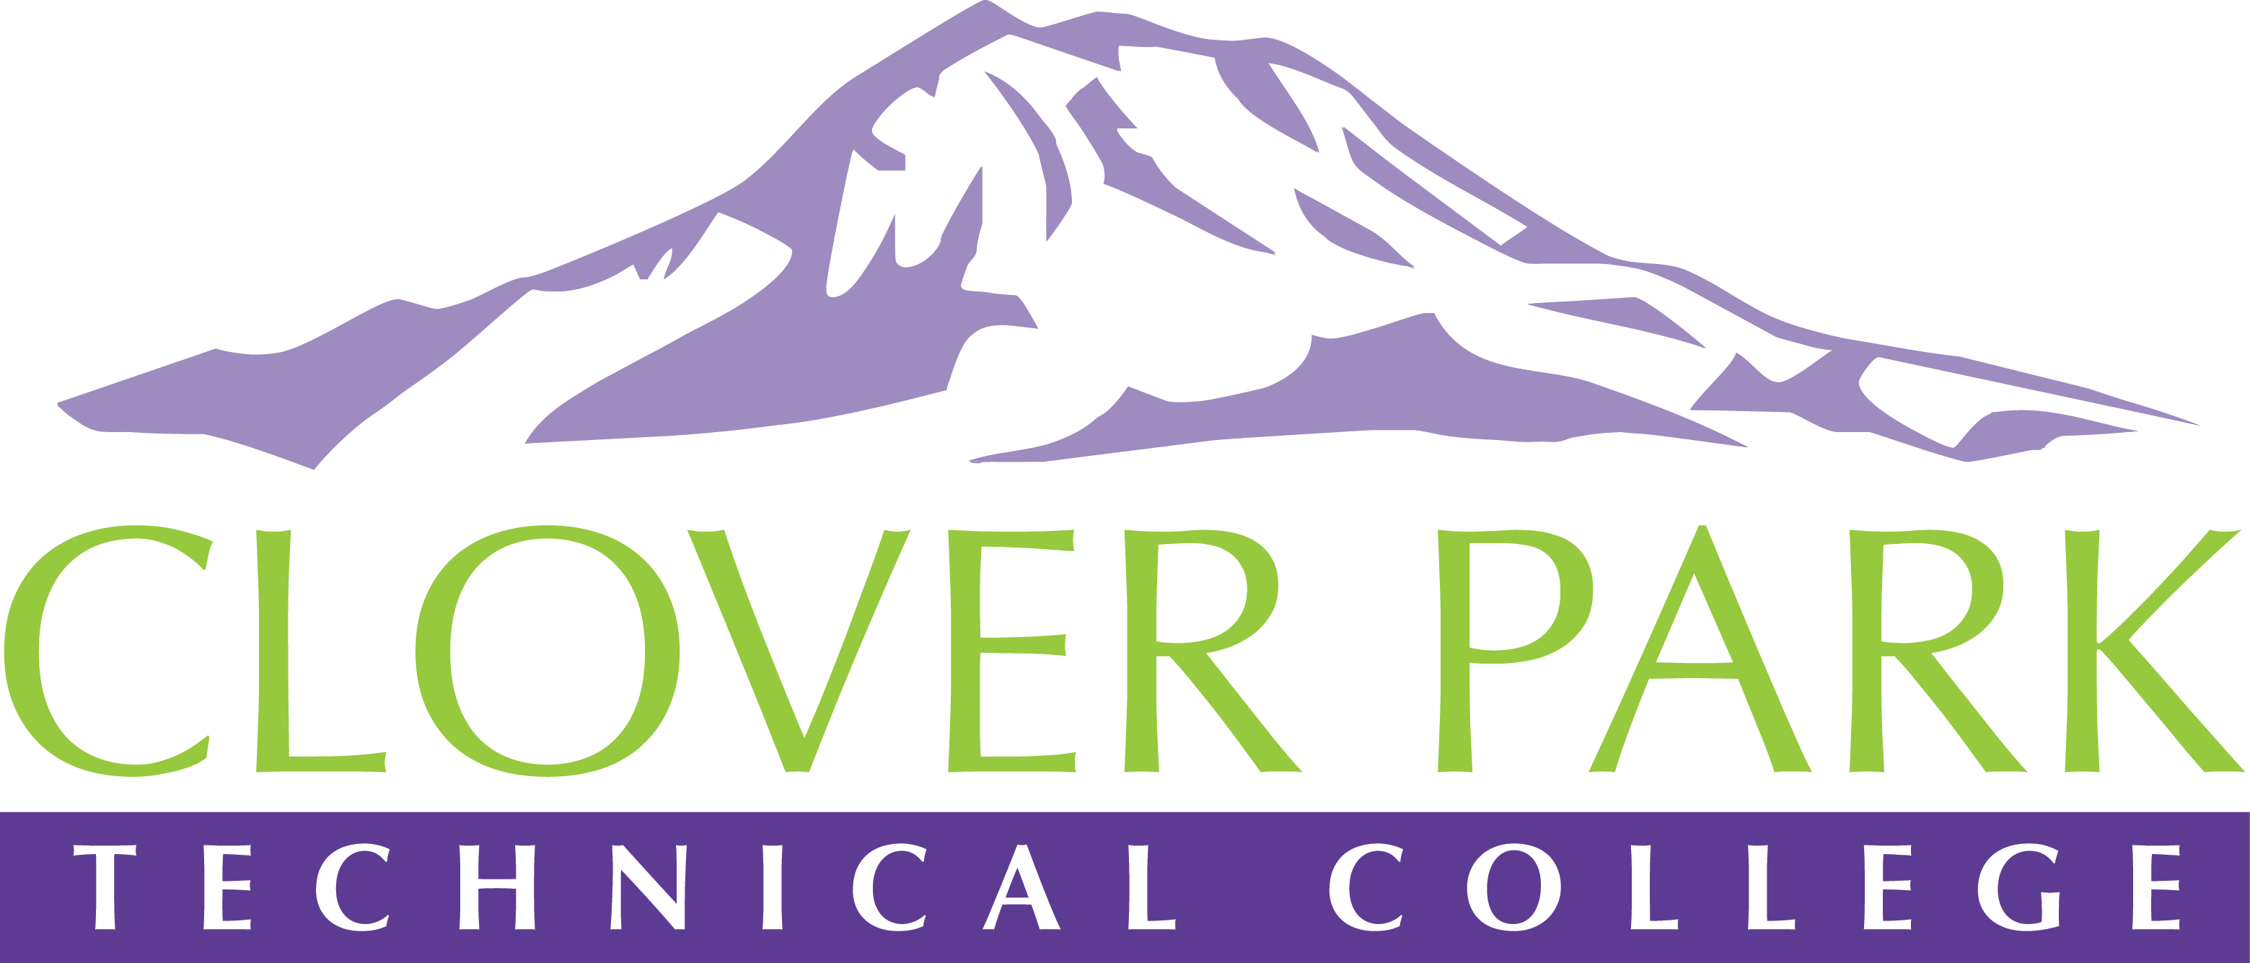

Accessible Technology Committee Action Plan

2019 - 2020

Summer Quarter 2019

Activate Accessibility Tools in Windows 10

IT will review all machines running on campus that are currently running the Windows 10 OS to make sure built-in accessibility features are activated and available for use.

Welcome New EDI Director

Jessica Carey and Pamela Jeter will meet with the new EDI Director in August to discuss accessible technology initiatives and needs on campus.

Committee Review of our 3.8 Draft Procedure

Members of the Accessible Technology Committee may submit edits to our draft procedure until the end of Summer Quarter.

Accessible Technology Committee Review

The ATC core team will be reviewing our current membership to determine if there are any gaps that need to be filled or if we should scale down.

VRI (Virtual Remote Interpreting) Service Trial*

Jessica will begin work during Summer Quarter to find grant opportunities to cover the cost running a trial of VRI services for our hearing impaired prospective students, current students, staff, and faculty. This trial will assess the level of campus need and continued cost in order to determine if this service will benefit the CPTC community.

*This item requires funds and completion is dependent on obtaining funding.

Fall Quarter 2019

3.8 Procedure Presented to E-Team

The ATC will have a completed version of the procedure for policy 3.8 submitted to E-Team for review at the beginning of Fall Quarter.

Expansion of SWAT Team

The ATC core team will work on developing the expansion of our current SWAT (Students Working for Accessible Technology) Team. Currently the SWAT Team reviews Canvas course for accessibility issues. We’d like to expand this scope so that the SWAT Team may also provide hands-on help to faculty and staff with creating accessible materials. Currently, Jessica, Kelley, and Cindy are the only staff on campus who provide hands-on help with accessible materials and cannot handle the work load alone. Work will continue into Winter Quarter.

Accessible Training Initiatives

The ATC core team will begin working with key personnel on campus during Fall Quarter to determine the best way to move forward in regards to ensuring that all faculty and staff have accessibility training. Work will continue into Winter Quarter.

Accessible IT Pages

Pam will be working with her team to review IT pages (linked to from our main and staff intranet sites) for accessibility compliance.

Accessibility Budget

ATC members will begin work during the Fall Quarter to determine what steps need to be taken to request a yearly, on-going budget for accessible technology expenses. Work will continue into Winter Quarter.

Student Portal*

Pam and the IT Department would like to have the implementation of a Student Portal completed during Fall Quarter.

*This item requires funds and completion is dependent on obtaining funding.

Winter Quarter 2020

Review Online Course Offerings

Kelley and Cindy will be reviewing online course for accessibility and content issues.

Propose Full-Time Accessibility Coordinator Position

The ATC core team will begin working with key personnel on campus during Winter Quarter to determine the best way to move forward in regards to requesting this position. Work will continue into Spring Quarter.

Spring Quarter 2020

Goal: 500 Training Attendees

Jessica has set a goal of reaching 500 attendees from Accessibility Bytes, online, and professional development classes combined.

CPTC GAAD (Global Accessibility Awareness Day) Event

The ATC would like to produce a CPTC GAAD event (May 21, 2020) this year. Work on this event will start in Fall Quarter. We’d like this event to be open to the community. We will also be working on obtaining funding for this event to provide extras (food, drink, guest speaker, swag).

Items from 2018-19 that will Continue in 2019-20

Accessibility Bytes and Online Trainings

The ATC will continue to offer Accessibility Bytes sessions once per quarter. ELearning will offer online training options continuously throughout the year.

Professional Development and In-Service

The ATC will continue to offer training services/sessions for professional development/in-service days.

Campus-wide Meetings

The ATC will continue to hold campus-wide meetings for Fall, Winter, and Spring Quarters.

Engagement and Buy-in

The ATC will continue to work on engaging the campus community to create accessibility buy-in.

Engagement Captioning Funds*

The ATC will continue to work on generating funding for captioning video (CaptionHub).

*This item requires funds and completion is dependent on obtaining funding.

