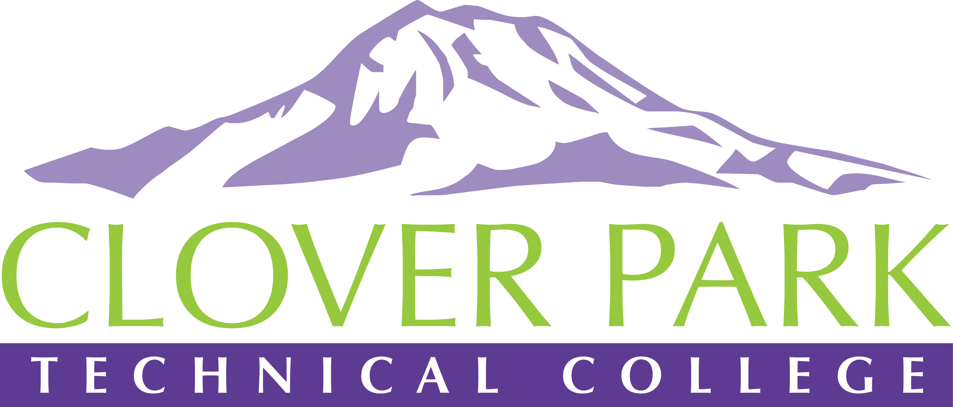

Accessible Technology Committee Meeting Minutes

May 15, 2019

Attendees:
Jessica Carey, Pam Jeter, Cindy Overton, Tyler Scott, Roland Alba

Outcomes on Meeting Topics:
- Access360 Grant Updates and Spring Convening Updates
Our CaptionHub account is about to have $4500 in it for video captioning services (just waiting on PRs to be processed. $2000 came from the Perkins Grant, $2500 came from our Access360 Grant.
Access360 may not be available next year. I have already started working with Sam to try to find other grant opportunities for us.
We did a share out of our greatest takeaways from the Access360 Spring Convening.
- Accessibility Bytes Trainings Updates and Requirements
It was decided by the co-chairs that the required training for committee members will be the SBCTC Accessibility Micro-Courses. Meeting attendees were polled and it was decided that the due date for completion is Dec 31, 2019.
For committee members who would like to help lead future Accessibility Bytes trainings, it is required for you to attend the current Accessibility Bytes trainings.
- Topic suggestions for next campus-wide meeting (June 10th)
Year in Review
Ally Report
Accessibility Awards
Possible Guest Speaker (hopefully Jess Thompson
- Open Floor
We need to schedule a 2nd meeting in June to go over our CPTC Procedure, take our final GOALS assessment, decide on meeting schedule for Summer Quarter.
- Assignment of Action Items
Sign up for Accessibility Bytes trainings. Sign up and get started on the SBCTC Accessibility Micro-Courses.

2018-19 Accessible Technology Committee Focus Areas
- Building up our team (diverse participation - including Faculty and Student representation)
- Building sub workgroups/committees to provide specific support to areas on campus
- Campus Training and Outreach (Accessibility Bytes, overhaul of Accessibility 101)
- Drafting a Procedure for our Policy (starting Winter 2019)

