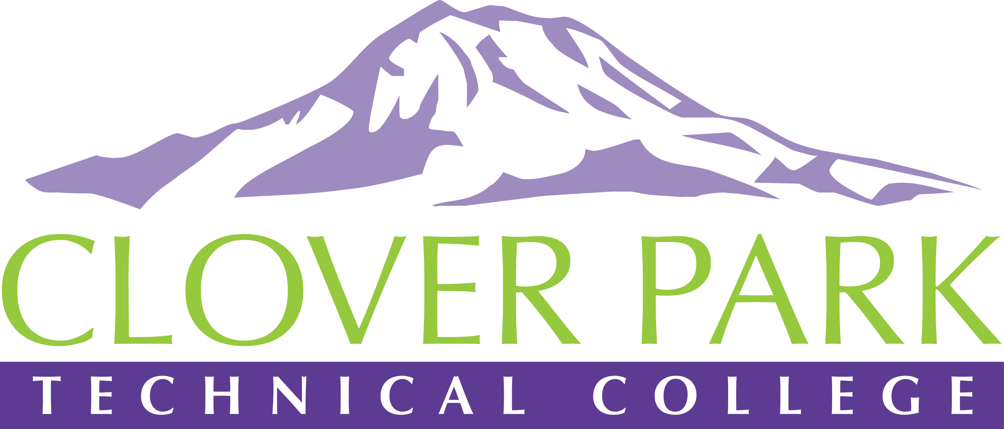

Accessible Technology Committee Meeting Minutes

April 16, 2019

Attendees:
Jessica Carey, Pam Jeter, Kelley Meeusen, Cindy Overton, Tyler Scott

Outcomes on Meeting Topics:
- Access360 Grant Updates and Spring Convening Updates
We discussed creating our CPTC Caption Hub account to add left-over grant funds into it for video captioning. I also announced that the ACT committee has been awarded funds from the Perkins grant (thanks to Tawny and Cristeen) to cover the set up costs of our Caption Hub account.
The core team was very happy to see how many new members we have joining us at the Spring Convening.
- Accessibility Bytes Trainings Updates and Requirements
The core team discussed the important of the committee members being trained in Accessible Technology topics in order to fulfill our goal of forming subcommittees to provide assistance and training across campus. Accessibility Bytes trainings and Accessibility 101 are now required to be taken by all committee members. Details regarding deadlines will be discussed at our next meeting. You can find the CPTC Accessibility 101 course on our staff intranet.
- Open Floor
We discussed how much we appreciate those who are diving into Accessible Technology guidelines and practices. From this discussion, we’ve decided to create Accessibility Awards that will be handed out quarterly at our campus-wide meetings.
- Assignment of Action Items
Sign up for Accessibility Bytes trainings once registration goes live. Sign up and get started on the Accessibility 101 course. You can find the CPTC Accessibility 101 course on our staff intranet.

2018-19 Accessible Technology Committee Focus Areas
- Building up our team (diverse participation - including Faculty and Student representation)
- Building sub workgroups/committees to provide specific support to areas on campus
- Campus Training and Outreach (Accessibility Bytes, overhaul of Accessibility 101)
- Drafting a Procedure for our Policy (starting Winter 2019)

