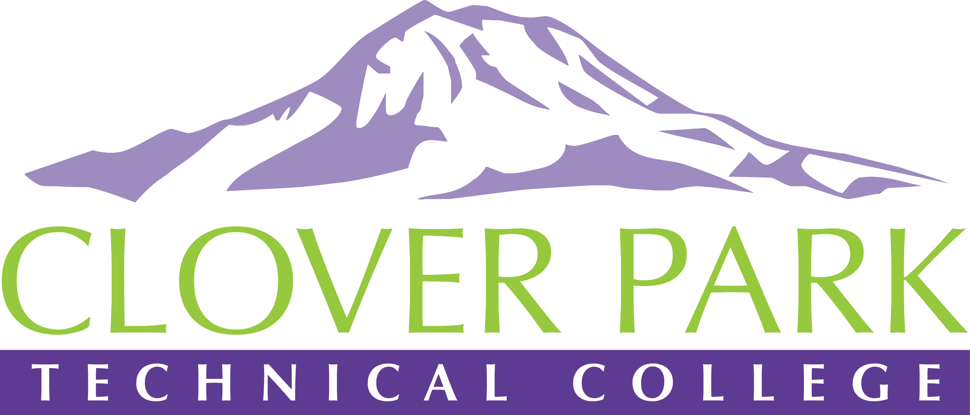

Accessible Technology Committee Meeting Agenda

September 27, 2018

Today’s Topics:
- (3:00) Open and Welcome New Members
- (3:05) Report Out of Aug Action Items
- (3:10) Access360 Grant Update
- (3:20) Open Floor – Open to provide feedback on committee work or raise concerns about practices on campus.
- (3:35) Assignment of action items
- (3:45) Close Meeting

2018-19 Accessible Technology Committee Focus Areas
- Building up our team (diverse participation - including Faculty and Student representation)
- Building sub workgroups/committees to provide specific support to areas on campus
- Campus Training and Outreach (Accessibility Bytes, overhaul of Accessibility 101)
- Drafting a Procedure for our Policy (starting Winter 2019)

