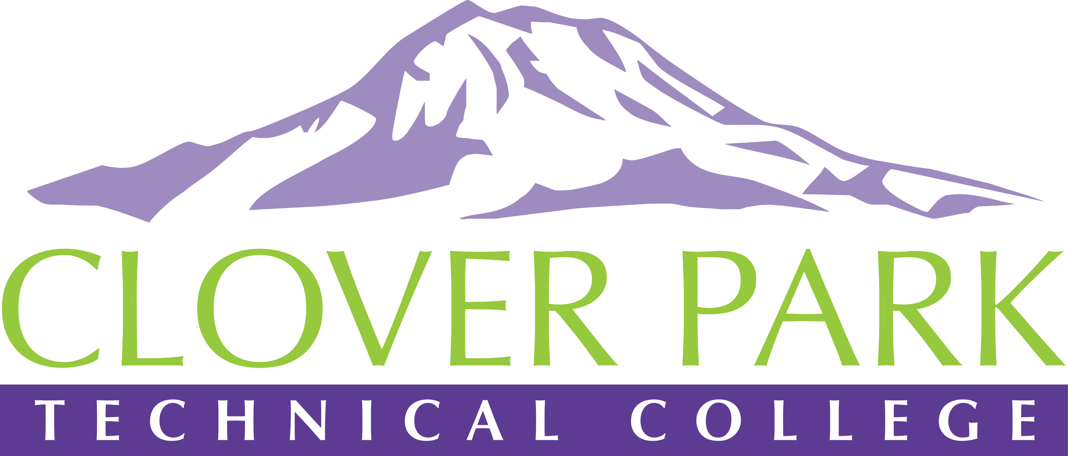

Accessible Technology Committee Meeting Agenda

November 27, 2018

Today’s Topics:
- (11:30) What is Accessible Technology and why does it matter?
- (11:40) Access360 Grant and Fall Convening updates
- (11:45) Report out of our Winter Quarter priorities
- (11:50) Ally report on the accessibility of our Canvas content
- (12:00) How can I start making my content more accessible TODAY? (Quick Tips)
- (12:10) Open Floor – Open to provide feedback on committee work or raise concerns about practices on campus.
- (12:25) Assignment of action items
- (12:30) Close Meeting

2018-19 Accessible Technology Committee Focus Areas
- Building up our team (diverse participation - including Faculty and Student representation)
- Building sub workgroups/committees to provide specific support to areas on campus
- Campus Training and Outreach (Accessibility Bytes, overhaul of Accessibility 101)
- Drafting a Procedure for our Policy (starting Winter 2019)

