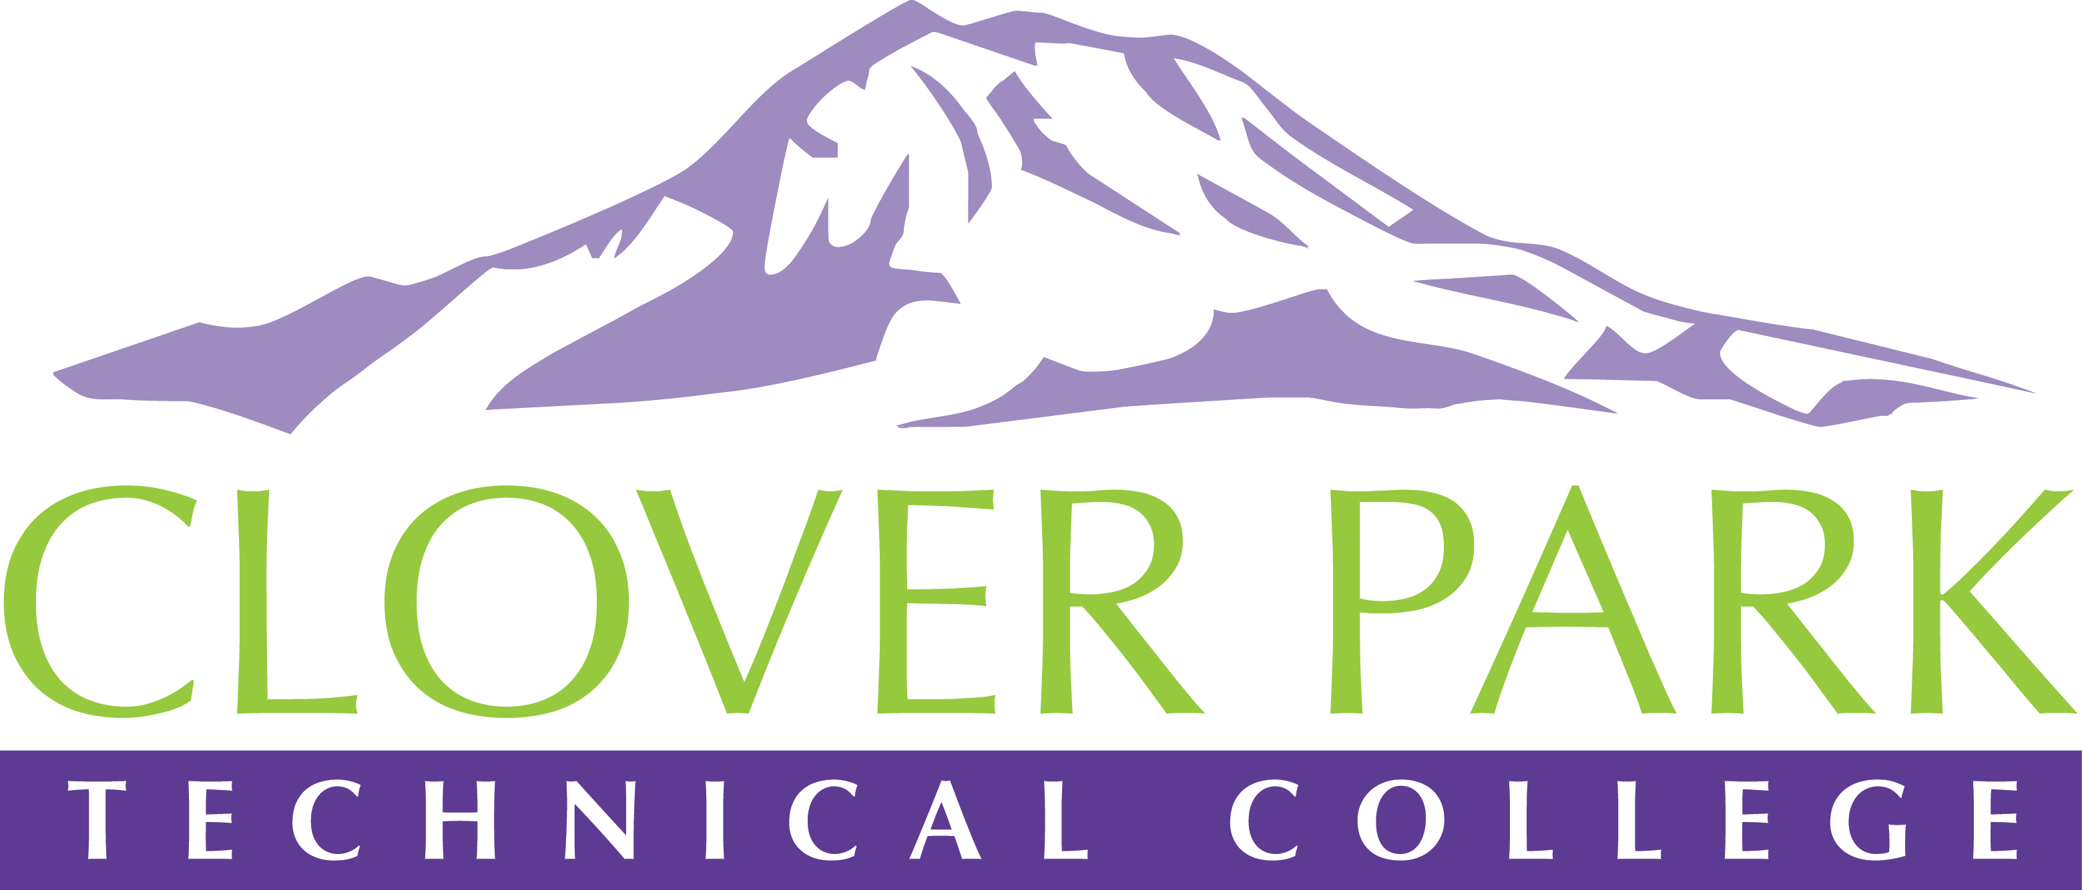

Accessible Technology Committee Meeting Agenda

March 14, 2019

Today’s Topics:
- (12:00) Welcome and Introductions
- (12:05) Access360 Grant Updates and Fall Convening Updates
- (12:15) Hidden vs. Visible Disabilities
- (12:25) How to Create Accessible Emails
- (12:35) Open Floor – Open to provide feedback on committee work or raise concerns about practices on campus.
- (12:45) Assignment of Action Items – upcoming trainings and Fall Convening list
- (12:50) Close Meeting

2018-19 Accessible Technology Committee Focus Areas
- Building up our team (diverse participation - including Faculty and Student representation)
- Building sub workgroups/committees to provide specific support to areas on campus
- Campus Training and Outreach (Accessibility Bytes, overhaul of Accessibility 101)
- Drafting a Procedure for our Policy (starting Winter 2019)

