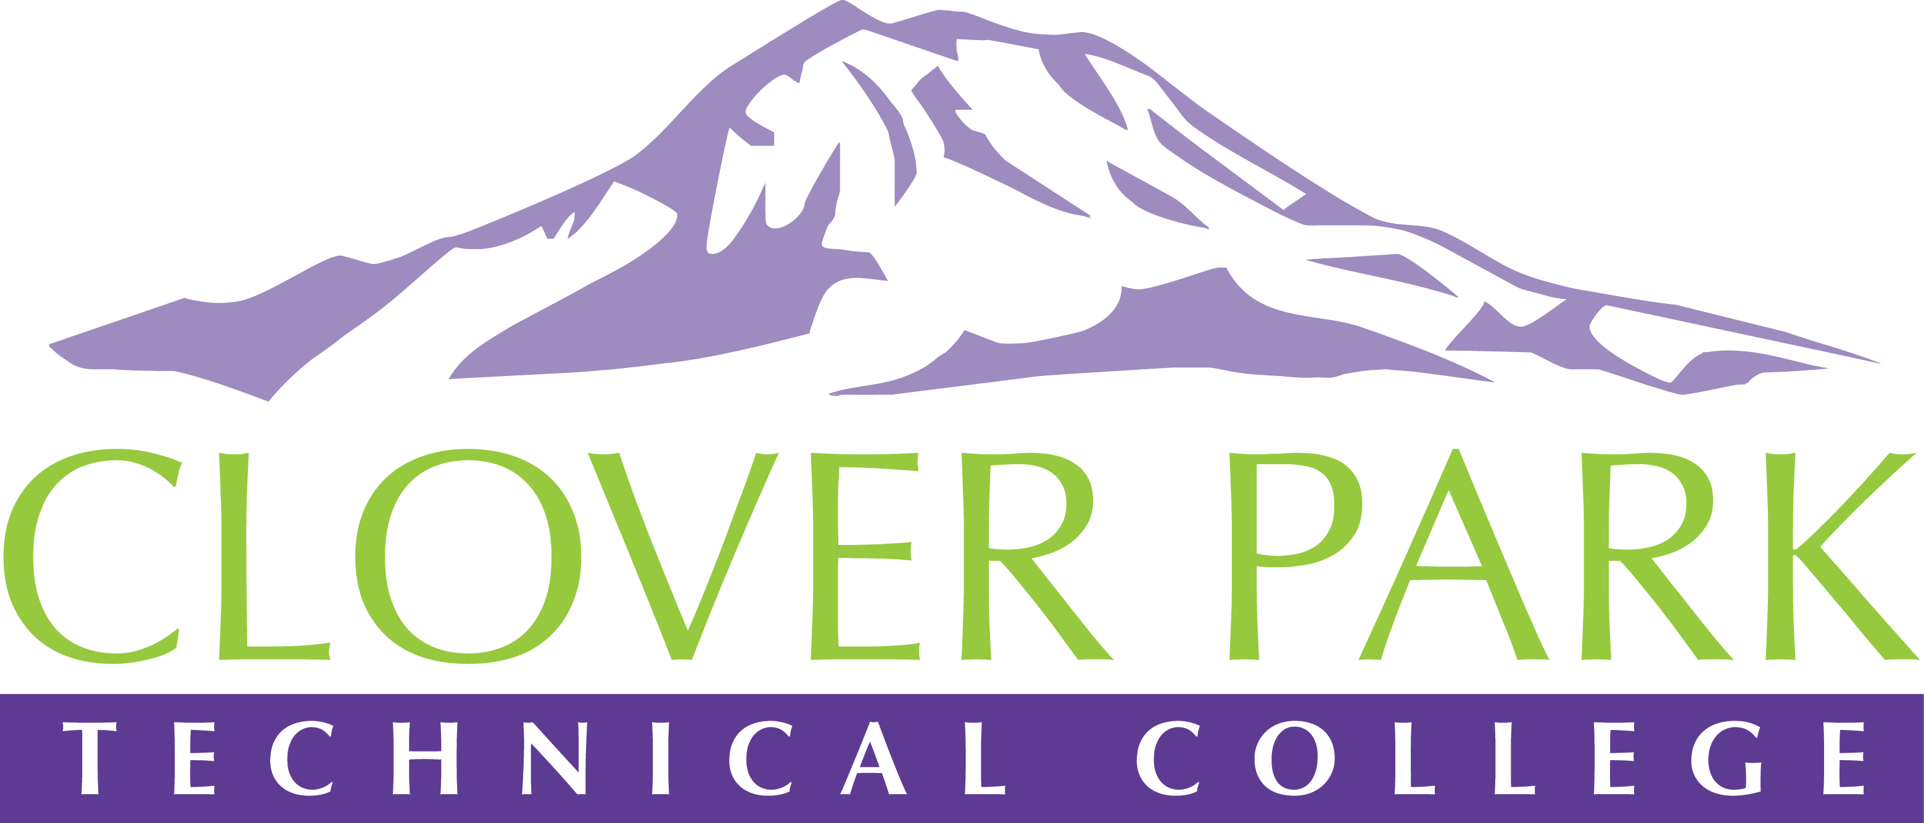

Accessible Technology Committee Meeting Agenda

June 10, 2019

Today’s Topics:
- (12:00) Access360 Grant Updates and Year in Review
- (12:10) Ally (Canvas Accessibility) Report
- (12:20) Special Guest - Jess Thompson, Program Administrator & Accessible Tech. Initiatives from SBCTC
- (12:35) Open Floor – Open to provide feedback on committee work or raise concerns about practices on campus.
- (12:45) Accessibility Awareness Awards
- (12:55) Close Meeting – No Action Items for June. Reflect on and an be proud of all of the hard work you’ve done this past year!

2018-19 Accessible Technology Committee Focus Areas
- Building up our team (diverse participation - including Faculty and Student representation)
- Building sub workgroups/committees to provide specific support to areas on campus
- Campus Training and Outreach (Accessibility Bytes, overhaul of Accessibility 101)
- Drafting a Procedure for our Policy (starting Winter 2019)

