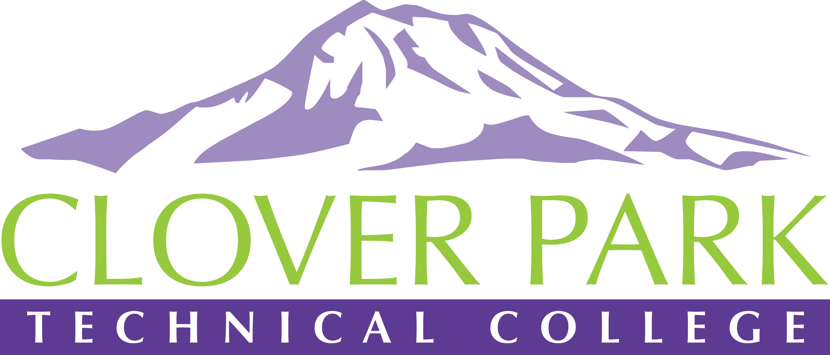

Accessible Technology Committee Meeting Agenda

January 8, 2019

Today’s Topics:
- (1:00) Open and Welcome New Members
- (1:05) Procedure for Policy 3.8 – Need Sub Committee
- (1:25) Accessibility Bytes trainings - Need Sub Committee
- (1:45) Open Floor – Open to provide feedback on committee work or raise concerns about practices on campus.
- (1:55) Assignment of action items (Beginning stages of drafting our procedure – need input from all departments)
- (2:00) Close Meeting

2018-19 Accessible Technology Committee Focus Areas
- Building up our team (diverse participation - including Faculty and Student representation)
- Building sub workgroups/committees to provide specific support to areas on campus
- Campus Training and Outreach (Accessibility Bytes, overhaul of Accessibility 101)
- Drafting a Procedure for our Policy (starting Winter 2019)

