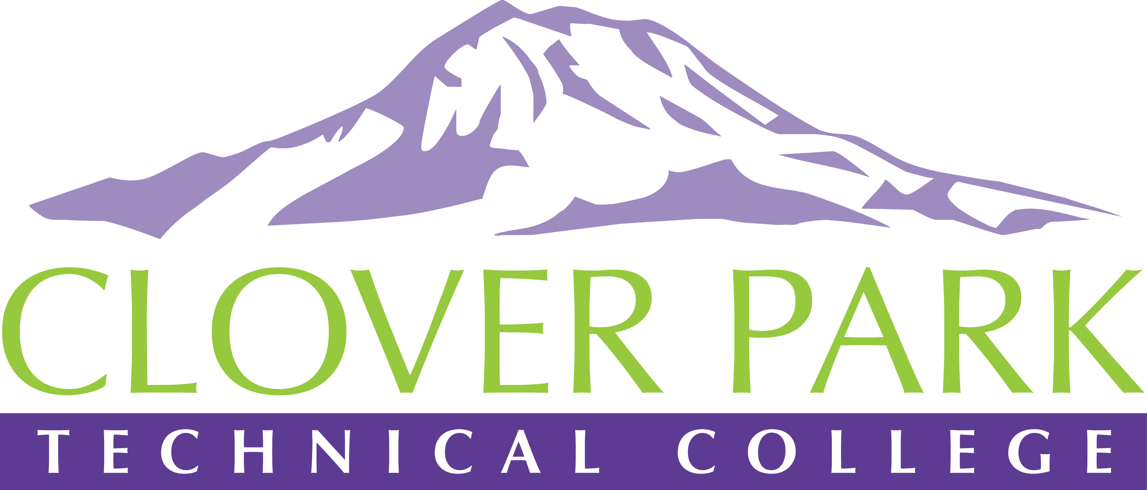

Accessibility Committee Meeting Agenda

August 29, 2018

Today’s Topics:
- (2:00) Access360 Grant Update
- (2:05) 2018-19 Potential Focus Areas:
- Building up our team (diverse participation - including Faculty and Student representation)
- Building sub workgroups/committees to provide specific support to areas on campus
- Campus Training and Outreach (Accessibility Bytes, overhaul of Accessibility 101)
- Drafting a Procedure for our Policy (starting Winter 2019)
- (2:10) Open floor – feedback on focus areas and suggestions for other focus areas
- (2:25) Open discussion – current accessibility issues on campus
- (2:50) Assignment of action items

