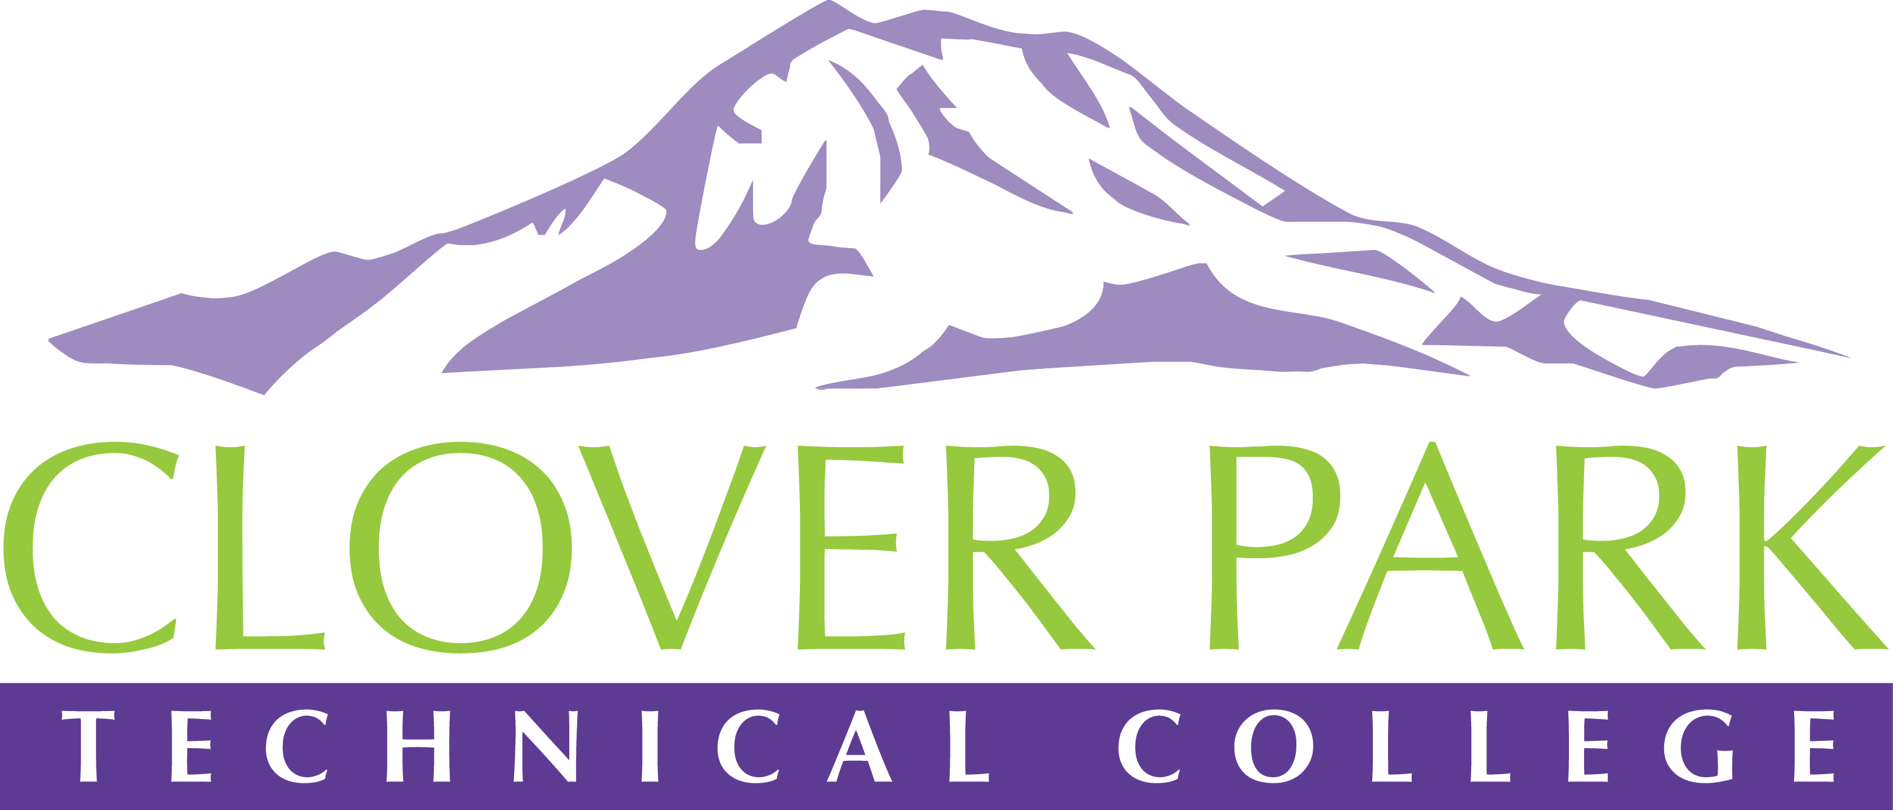

Accessible Technology Committee Meeting Agenda

April 16, 2019

Today’s Topics:
- (2:30) Access360 Grant Updates and Spring Convening Updates
- (2:45) Accessibility Bytes Trainings Updates and Requirements
- (3:00) Open Floor – Open to provide feedback on committee work or raise concerns about practices on campus.
- (3:10) Assignment of Action Items – Sign up for Accessibility Bytes trainings
- (3:15) Close Meeting

2018-19 Accessible Technology Committee Focus Areas
- Building up our team (diverse participation - including Faculty and Student representation)
- Building sub workgroups/committees to provide specific support to areas on campus
- Campus Training and Outreach (Accessibility Bytes, overhaul of Accessibility 101)
- Drafting a Procedure for our Policy (starting Winter 2019)

