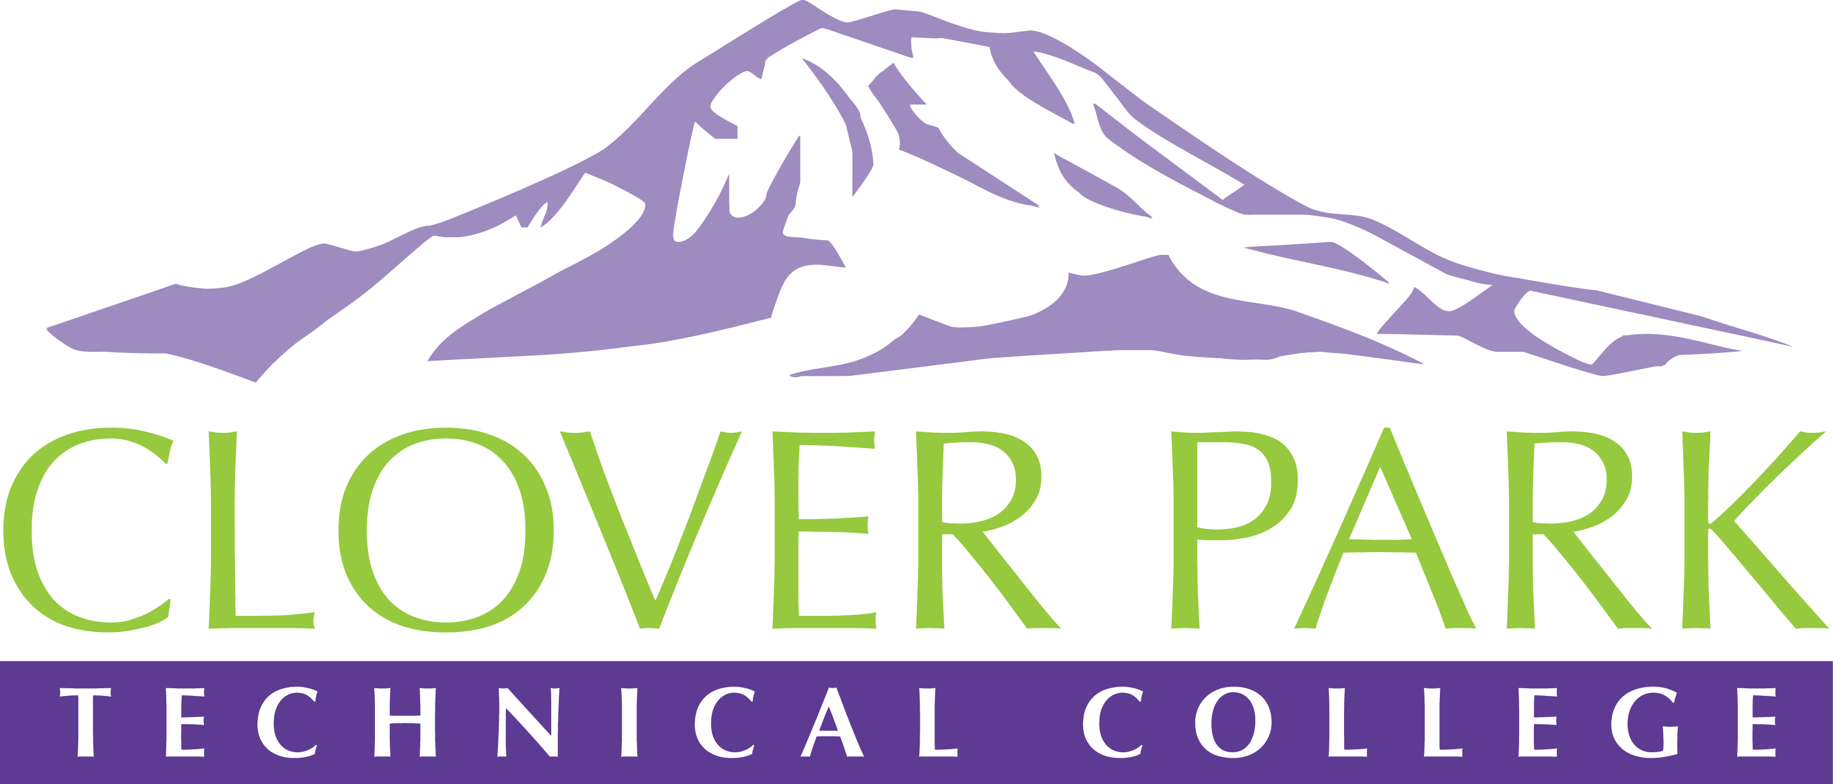

Accessible Technology Committee – Pre Spring Convening Meeting Agenda

April 17, 2019

Today’s Topics:
- (1:30) Overview of our Access360 Action Plan (will provide copies)
- (1:45) Review of the Spring Convening Agenda (will provide copies)
- (2:05) Travel Authorization and Travel Vouchers
- (2:20) Open Q&A
- (2:30) Close Meeting

2018-19 Accessible Technology Committee Focus Areas
- Building up our team (diverse participation - including Faculty and Student representation)
- Building sub workgroups/committees to provide specific support to areas on campus
- Campus Training and Outreach (Accessibility Bytes, overhaul of Accessibility 101)
- Drafting a Procedure for our Policy (starting Winter 2019)

